I. Home Page: The Critical Imperative
Headline: Ensuring Operational Continuity in an Interconnected Sky and SMART airport
The Reality of Modern Aviation The modern civil aviation landscape comprising ground infrastructure, logistics, and passenger services is a digital frontier. Connectivity has introduced unprecedented risks, where a single breach in the supply chain can lead to total operational paralysis.
The Challenge by the Numbers
- Total Ecosystem Exposure: 100% of the civil aviation ecosystem, from primary terminals to the boutique supply chain vendors, is a potential entry point for systemic threats.
- The Cost of Downtime: Beyond loss of revenue, data theft, and cyber-attacks, this sector's downtime results in immediate operational stoppages due to security concerns and the erosion of public trust.
- Regulatory Imperative: Compliance with ICAO and other international and national regulators standards is no longer optional; it is a prerequisite for "Tender Readiness".
The AeroCy Solution AeroCy bridges the critical gap between flight safety and digital security. We provide a comprehensive protective envelope that ensures your infrastructure remains resilient against evolving threats while maintaining strict regulatory adherence.

II. About Us: Our Pedigree and Vision
The AeroCy Narrative AeroCy was founded to provide international-grade operational resilience for civil and general aviation. Our company is built on three decades of experience in critical infrastructure protection and, the forefront of technology and AI and, a robust academic foundation at the forefront of cyber research.
Our Tech Roots in CyRay AeroCy leverages the elite technological framework and state-level detection capabilities of CyRay. By utilizing CyRay’s proven methodology and extensive experience in Israel's' national infrastructure and specifically Israeli civil aviation cybersecurity, we have optimized world-class SIEM technology specifically for the aviation domain.
AeroCy AVSEC Origins AeroCy has three decades of experience in civil aviation security at an international level based on Intelligence Driven Security, an Israeli AVSEC specialized company. Our security concept is based on operational experience, dealing with diverse international adversaries. The concept provides a response to threats while relying on quality intelligence. The response includes a balance between quality human resources, dedicated technology for aviation threats, and international procedures.
Leadership & Founders
- Executive Strategy: Our leadership focuses on global strategy, finance, and high-level partnerships with entities such as the TSA and national aviation authorities to ensure our clients have the necessary professional backing.
- Technical Excellence: Our technical office specializes in "IT/OT Fusion," adapting state-of-the-art AI driven monitoring tools to the specific protocols of aviation.

III. Services: The Ecosystem of Defense
Our concept: Risk-based, Threat-oriented, Intelligence-driven holistic solution.
AeroCy provides a holistic suite of services to secure every link in the civil aviation chain:
- Hybrid Threat Monitoring (IT/OT/IoT/e-Operation/ Data): Continuous detection across all layers, from standard information systems to operational technology and internet-based devices.
- Vendor Shield (Supply Chain Hardening): A specialized technical and regulatory kit designed to audit, verify, and secure the entire vendor network.
- Regulatory Compliance & Audit: Expert guidance to ensure your organization meets the rigorous demands of ICAO, and IATA, EASA, ACI, FAA etc.
- Crisis Management & Resilience Testing: Comprehensive crisis response services and penetration testing for aviation-specific applications, such as Electronic Flight Bags (EFB).

V. Contact Us: Consultative Engagement
Secure Your Future Operations Aviation security is established through trust and meticulous planning. We invite CISOs, Safety Managers, and Operations Directors to engage in a focused Risk Assessment or a non-disruptive Proof of Concept (POC).
- Corporate Inquiries: [info@aerocy.io]
- Strategic Partnerships: Connect with our Advisory Board.

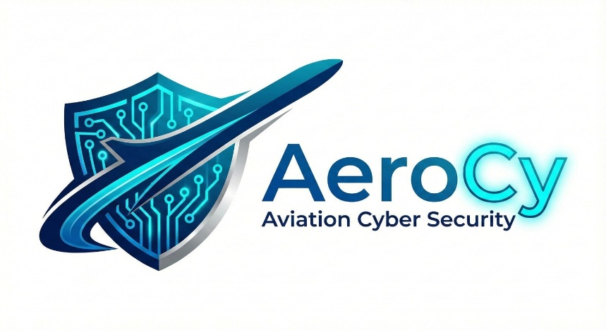

Logo

Product - Services – Technology – Concept – Contact

Our Services:
- Monitoring & Intelligence
- Compliance
- Regulatory Preparedness
- Crisis Management
- Business Continuity
- Reputation Protection
- Technological Readiness
- Governess & Liability

Our Technology:
Powered by advance detection and proprietary algorithm
- Our technology approved by Israel government to protect Israeli airlines
- Our technology protects Ben-Gurion Airport
- Over 1000 civil aviation specific detection rules deployed immediately
- Full SIEM/SOC Integration
- Continuous real-time rules updates
- Full AI driven

Our Concept:
A holistic cybersecurity approach built on three pillars:
- Risk-based: Prioritizing critical assets and high-impact scenarios
- Threat-oriented: Focusing on actual adversaries and attack vectors
- Intelligence-driven: using self and global intelligence to preempt attacks

Contact:
Itay@ids-opt.com
+972-524888580
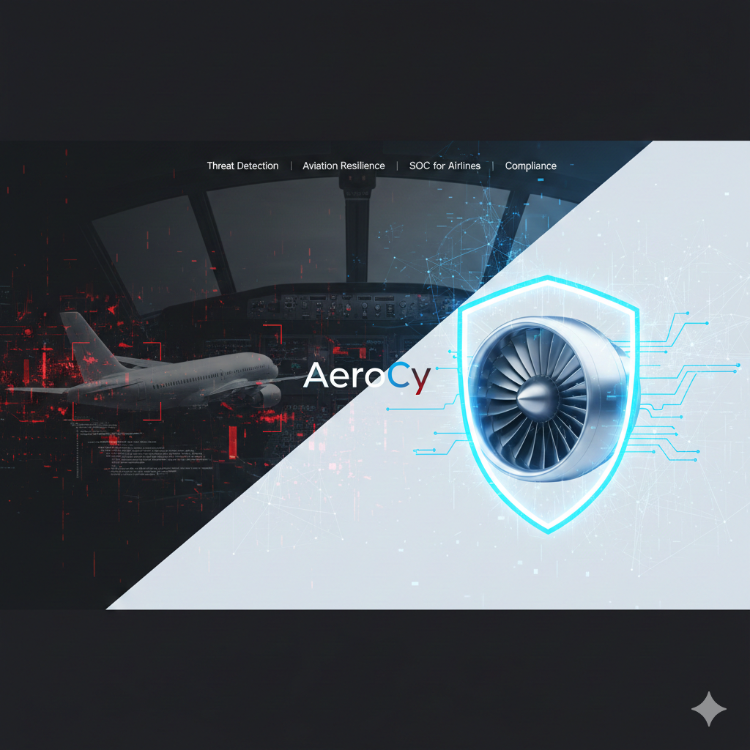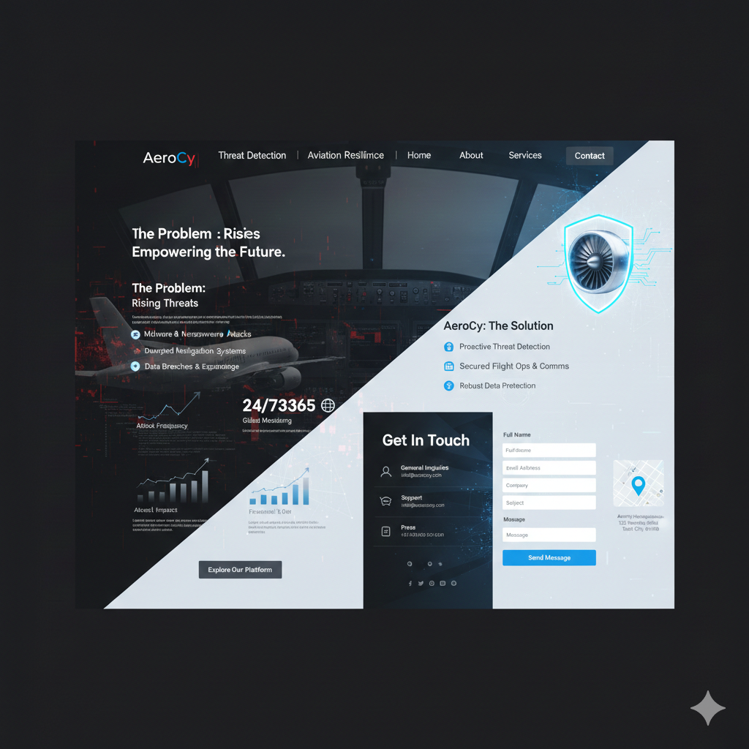

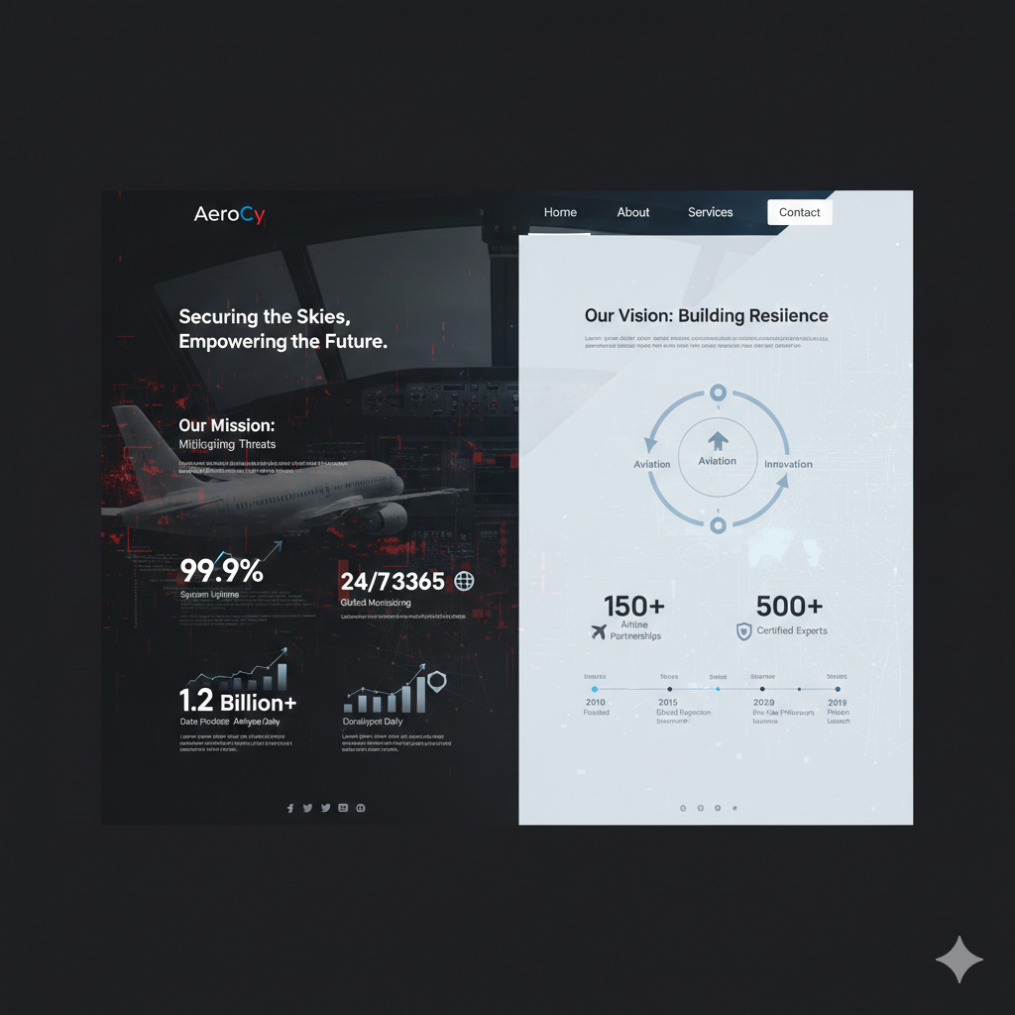

Graphic Description
Based on the vision of AeroCy as a leader in aviation resilience and its roots in CyRay’s elite, state-level detection technology, the graphic design should project a balance of high-stakes security and operational stability.
The visual language will utilize a "Split-Theme" aesthetic to represent the core challenge and the AeroCy solution.
"Red" side of threats and "Blue" side of solutions.

Visual Identity & Theme
- The Duality Concept: The design features a diagonal split-screen layout. The "Threat" side uses dark tones and red digital glitches to represent cyber risks to aviation, while the "Resilience" side is clean, bright, and uses "Cyber Blue" to represent the AeroCy protective envelope.
- The IT/OT Fusion: Imagery includes 3D renders of aviation hardware (turbines, cockpits) overlaid with digital HUDs and network nodes, visually representing the integration of Information Technology and Operational Technology.
- The AeroCy Logo: A futuristic, aerodynamic sans-serif font. The "Cy" reflects the branding heritage of CyRay, signaling the leverage of their established technology and reputation.
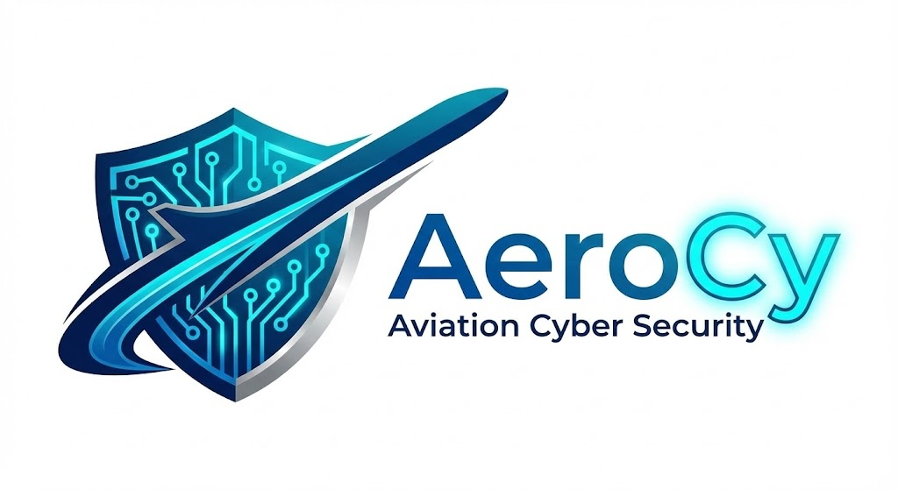

Page-Specific Design Elements
- General: civil aviation motives: airport, aircraft, airport landing instruments, aircraft cockpit, air traffic control tower, passenger entertainment system, booking and reservation system, passport control,
- Home Page (The Challenge): This section utilizes dynamic data visualizations—real-time graphs and counters—showing the 100% exposure of the aviation supply chain to digital threats. Constant threats are shooting at a cyber shield.
- About Us (The Narrative): A timeline-based layout showing the transition from CyRay’s state-level security to AeroCy’s specialized aviation focus. It includes professional, high-contrast portraits of the leadership team and the Advisory Board members.
- Services (The Solution): Each service (e.g., Vendor Shield, Crisis Management) is represented by a distinct, technical icon. The "Vendor Shield" is highlighted with a glowing holographic shield icon protecting a commercial aircraft.
- Blog & Thought Leadership: A "Command Center" aesthetic, using monospace fonts and data-heavy layouts to mimic professional research reports and Whitepapers.
- Clients: Israel MOT, Arkia, Israir,
Typography & Color Palette
Element | Style / Color | Purpose
Primary Color | Deep Navy & Slate | Represents stability and CyRay’s security roots.
Accent Color | Electric Cyan | Represents innovation and the "Resilience" side.
Warning Color | Alert Red | Used sparingly on the "Threat" side to highlight vulnerabilities.
Headings | Bold Sans-Serif | Conveys authority and a modern, "tender-ready" image.
Body Text | Monospace / Modern Serif | Evokes a technical, academic, and professional feel.

I want as many as possible images and minimum writing
Similar Websites for Inspiration:
Site | Focus | Why useful to look at
ICAO – Aviation Cybersecurity  https://www.icao.int/aviation-cybersecurity | UN-level aviation cyber policy and guidance.AeroCy-Website-instructions.docx​ | Clean, institutional regulator look; good reference for how to present “regulatory imperative” and high-level diagrams.
ACI – Airport IT Cybersecurity  https://aci.aero/airport-advocacy/airport-information-technology/cybersecurity/ | Global airport council cybersecurity section.AeroCy-Website-instructions.docx​ | Shows how airport-side cyber topics (IT/OT, operations continuity) are grouped and visually framed.
Cyviation  https://cyviation.aero | Cybersecurity solutions for commercial airlines and business jets.cyviation​ | Direct aviation-cyber vendor; check how they design hero, value props, and aircraft-centric visuals.
Guarded Globe – Airport Cybersecurity  https://www.guardedglobe.com/industries/airport-cybersecurity | Cyber advisory services for airports (commercial, cargo, executive).guardedglobe​ | Good for seeing how consulting services, TSA/FAA language, and risk-based offerings are laid out.
Aviation Relations – Aviation Cybersecurity for Airports  https://aviationrelations.com | Expert resources and consulting for airport cybersecurity readiness.aviationrelations​ | Look at how they talk to airport managers, structure service bullets, and present “readiness” messaging.
Honeywell – Aerospace Cybersecurity Solutions  https://aerospace.honeywell.com/us/en/products-and-services/product/services/aerospace-cybersecurity-solutions | Large OEM’s aerospace cyber offering, focused on connected aircraft and layered security.aerospace.honeywell​ | Useful for big-brand treatment of “end-to-end” cyber, assurance center visuals, and benefit framing.
IATA – Security Consulting  https://www.iata.org/en/services/consulting/airports/security/ | Broader aviation and airport security consulting (not only cyber).iata​ | Good reference for serious/tender-oriented styling, sectioning of services, and regulator-aligned language.

VI. UI & Navigation: Button Placements
(Note for designer: Replace text descriptions with icon-heavy buttons and minimal labels where possible)
1. Home Page
- View Threat Dashboard: Directs to dynamic data visualizations and counters.
- The AeroCy Solution: Links to the protective envelope details.
- Ensure Tender Readiness: Anchors to the ICAO/regulatory compliance section.
- Explore Our Platform: Primary Call-To-Action (CTA) leading to services.

2. About Us
- The AeroCy Narrative: Triggers the timeline showing the transition to aviation focus.
- Our CyRay Heritage: Anchors to state-level detection background.
- Meet Leadership: Jumps to the high-contrast portraits of the executive team.
- Technical Excellence: Links to the "IT/OT Fusion" methodology.
- Hybrid Monitoring: Icon-based button for IT/OT/IoT detection.
- Vendor Shield: Glowing holographic shield icon button.
- Compliance & Audit: Icon-based button for regulatory guidance.
- Crisis Management: Icon-based button for resilience testing.

4. Contact Us
- Request Risk Assessment: Opens a specialized consultation form.
- Schedule a POC: Opens a request for a non-disruptive Proof of Concept.
- Corporate Inquiries: Direct mailto: link for info@aerocy.io.
- Strategic Partnerships: Connects to the Advisory Board network.

